|  |
| --- |
| Name: W N D PERERA |
| Student Reference Number: 10707045 |



|  |  |  |
| --- | --- | --- |
| Module Code: [PUSL2003](https://dle.plymouth.ac.uk/course/view.php?id=50723) | Module Name: [Integrating Project](https://dle.plymouth.ac.uk/course/view.php?id=50723) | |
| Coursework Title: Project proposal 2020/2021 | | |
| Deadline Date: 31/10/2020 | | Member of staff responsible for coursework: Mr. Upulanka Premasiri |
| Programme: [BSc (Hons) Computer Security](https://dle.plymouth.ac.uk/course/view.php?id=14547)  [BSc (Hons) Software Engineering](https://dle.plymouth.ac.uk/course/view.php?id=14547) | | |
| Please note that University Academic Regulations are available under Rules and Regulations on the University website [www.plymouth.ac.uk/studenthandbook](http://www.plymouth.ac.uk/studenthandbook). | | |
| Group work: please list all names of all participants formally associated with this work and state whether the work was undertaken alone or as part of a team. Please note you may be required to identify individual responsibility for component parts.   |  |  | | --- | --- | | W N D PERERA | Project and Group Leader  Quality Leader | | P A A S PERERA | Planning Leader | | D L S AKBO | Programming Leader | | B R A FERNANDO | Technical Leader  Testing and Maintenance Leader |   ***We confirm that we have read and understood the Plymouth University regulations relating to Assessment Offences and that we are aware of the possible penalties for any breach of these regulations. We confirm that this is the independent work of the group.***  Signed on behalf of the group: W N D PERERA | | |
| Individual assignment: ***I confirm that I have read and understood the Plymouth University regulations relating to Assessment Offences and that I am aware of the possible penalties for any breach of these regulations. I confirm that this is my own independent work.***  Signed: | | |
| Use of translation software: failure to declare that translation software or a similar writing aid has been used will be treated as an assessment offence.  I *have ~~used~~/not used translation software.  If used, please state name of software………………………………………………………………… | | |
| **Overall mark _____% Assessors Initials ______ Date_________** | | |



**PUSL2003 Integrating Project**

**Project Proposal 2020/21**

**Fingerprint & NIC QR Reader based voting System**

### Group Name: Dream Epic

Members:

|  |  |  |
| --- | --- | --- |
| ID | Name | Degree Program (SE/CN/CS) |
| 10707046 | P A A S PERERA | CN |
| 10707045 | W N D PERERA | CN |
| 10707126 | D L S AKBO | SE |
| 10707197 | B R A FERNANDO | SE |
|  |  |  |
|  |  |  |

Introduction for Fingerprint and NIC QR based voting System

In recent eras over all countries we have seen development in ICT, that has been imposed on government and as well as private sector for modernization and improvements in these industries which we have seen outstanding results due to ICT implementations.

Government voting is one of the main economic activities of a country however this important factor especially in third world countries is seen as broken or unreliable, this had led to many reflections on how to overcome these issues. The Voting centre systems are one of the major vulnerabilities or weak points we can see in the system especially a country like Sri Lanka.

This is majorly caused as the voting centre uses ballotin unit and control unit voting also it has manual approach verifications and requires polling officers to allow the voting to take place, during this process there can be illegal voting and cheating, as well as some people can lose their right to vote one of the most basic human rights .These are some major issues seen in developing countries due to manual approach implementation.

Therefore, this is saying one thing there is a major change in need for a better system which is highly secured, reliant and has much accuracy in counting votes voted by the votes. This would provide the solutions to the problems a country like Sri Lanka would face during this process of election. Whereas a Fingerprint recognition technique which is much popular biometric technique is much better suited and in combination of NIC Reader would provide much higher reliance and accuracy.

The Fingerprint and NIC Reader based voting system would work as very efficient and highly accurate System. As Fingerprint recognition biometric technique uses people’s fingerprints which is different from a person to person, the system would be much precise and reliant and combination of NIC Reader would stop invalid votes and prevent people losing their human right to vote.

Therefore, the Fingerprint and NIC Reader based voting can be proposed a system for making dynamic changes for future betterment for the country.

Prime Objectives

The Fingerprint based voting system which is based on fingerprint matching biometrics is much advance as well as sets high standards in comparison, to the manual ballotin unit systems, there are many advantageous due to this approach implementation that’s the main idea for the development.

The Main Advantages are:

1. Reduce corruption: As the previous method of voting system which is inefficient and unreliable this new approach is much high standard and provides much high security and reliability and reduces corruption.
2. Improve accuracy: The system uses biometric technique of fingerprint that’s much accurate and reliable than previous manual approach because all peoples fingerprint is different from one another proving much accuracy.
3. Reduce Cost : During elections so much paper work and people are enforced to work during election , such times the local government spend large sums of money due to the manual approach (using labour) and this implementation can help to reduce the cost of for the government which in turn can be spend elsewhere for improvement of living standard of people , which is less likely seen in democratic or developing countries like Sri Lanka as they spend millions of dollars on a single election conduct .
4. Improve Economy Standards: When especially one of the main areas of the economy improves the economy, standards are to be gradually increased, this is due to cause and effect scenarios we see in day to day life.

# Approach/Methodology

The methodology or approach for the proposed system would be a privacy protected authentication system which is developed along with the fingerprint templates in the hosted database, the fingerprint templates are collected before election dates atgrama niladhari division and stored for use in future elections.

During election times at election centre the voter will have to verify his NIC through the QR Reader and then the fingerprint templates would be used for verification at voting centre , whereas if matched the voter is allowed to vote or else is not eligible and the system strictly checks for repeated voting and it wouldn’t allow one candidate to vote more than once. All coding is done through IDE of Arduino to Arduino mega board.

The System Designing would contain some major implementations that can be expressed in steps for simplicity:

1. Appoint a date at grama niladhari division for submission of fingerprints:

* The voters who are eligible to vote will be asked to go to the grama niladhari division at a specific date for the submission of fingerprint templates which will saved in local government servers.

1. Participation in Election:
2. Scan the NIC:

* The candidate must scan their NIC for verification thus avoiding repeated voting, that’s scan and registered in the database along with the fingerprint template.

1. Scan the fingerprint:

* The candidate would have to input their fingerprint that would be matched against their fingerprint template and if it checks out the candidate would be able to vote for a party that they prefer through the Voting Unit and if Declined Voter is unable to vote.
* Finally, the outcome is printed for further needed references if required.

The system plan and implementation are provided in the System Plan Section in [6].

Resource Requirements

The proposed system requires some hardware equipment’s like:

1. Arduino Mega.
2. Fingerprint scanner
3. QR Reader
4. LCD display
5. Printer
6. PC
7. Cassin’s
8. Voting Unit
9. Power Supply

The implementation of the system would be shown in the system block diagram given below:

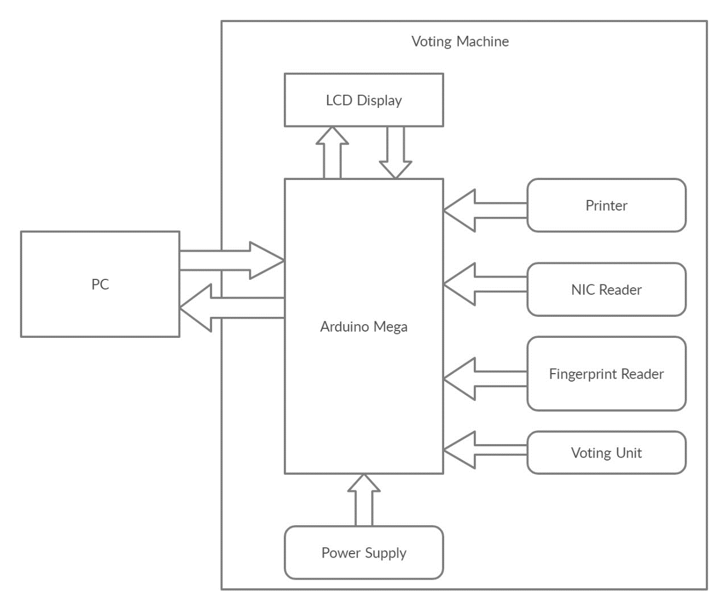

Project Plan

* The project will be initiated on December and approximated to be completed by the end of February.

Reference

* Bazen, A.M., Gerez, S.H.: Systematic Method for the Computation of the Directional Fields and Singular Points of Fingerprints. IEEE Transactions on Pattern Analysis and Machine Intelligence 24, 905–919 (2002)
* Maio, D., Maltoni, D.: Direct Gray-Scale Minutiae Detection in Fingerprints. IEEE Transactions on Pattern Analysis and Machine Intelligence 19, 27–40 (1997)
* (Maltoni et al., 2009) Maltoni, D., Maio, D., Jain, A. and Prabhakar, S. (2009) Handbook of Fingerprint Recognition, 2nd edition, London: Springer.
* C. Z. Geevar, P. Sojan Lal, "Reference point estimation in fingerprint image", Computational Intelligence and Computing Research (ICCIC) 2010 IEEE International Conference on, pp. 1-4, 2010.